

A

Project Report On

**BUS TICKET BOOKING**

**SUBMITTED BY ,**

**Mamta kurrey (2022-8654)**

**Bhavana bhavisker (2022-8654)**

**Preethi S (2022-8653)**

**Dinesh Patil (2022-8655)**

**Siddhanath Bhopate (2022-8655)**

**Shaik Sameer (2022-8653)**

## Center: Bangalore CG AWS

Under the Guidance of,

## JAYANTH VELLINGIRI.

**(EON Master Trainer)**

**EduBridge**

(School of coding)

**Introduction:**

Our project explains about the Online Bus Ticket Booking. This project mainly explains the various actions related to book ticket online by siting at anywhere. You can search for buses and available seats and tickets as well. You can also search for a place where you want to go.Our Project Includes,

## Modules:-

* Admin Module
* Customer Module

We have developed this Application in **Java.** It’s a console-based projects.

The main objective of this project is to book bus ticket, keep a record of bus, customer, transactions, etc.

Admin can manage bus details, see transactions, see bus details, add buses information, customer information etc. ,For using this application admin and customer both have to login first.

Customer can book a ticket if the customer is already registered to the system. Customer can see available buses, their prices, remaining seats.

**Operating Environment:**

**Tools Used**: Eclipse IDE

**Operating System:** Window 11.

# Screenshots:-

**Home Page:**

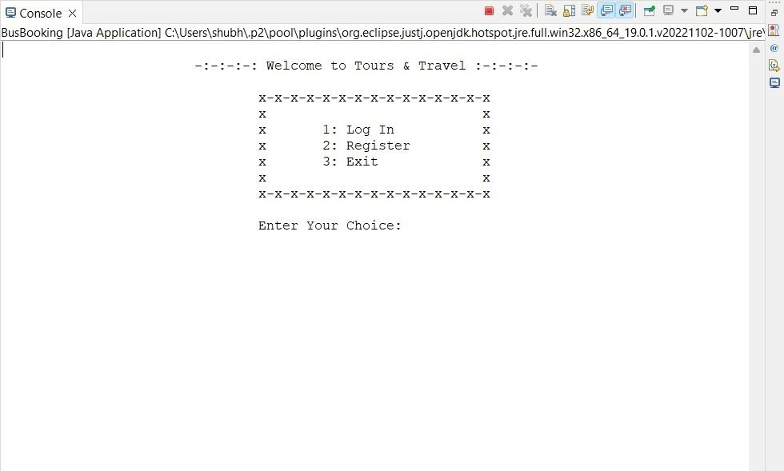

**Registration Page:**

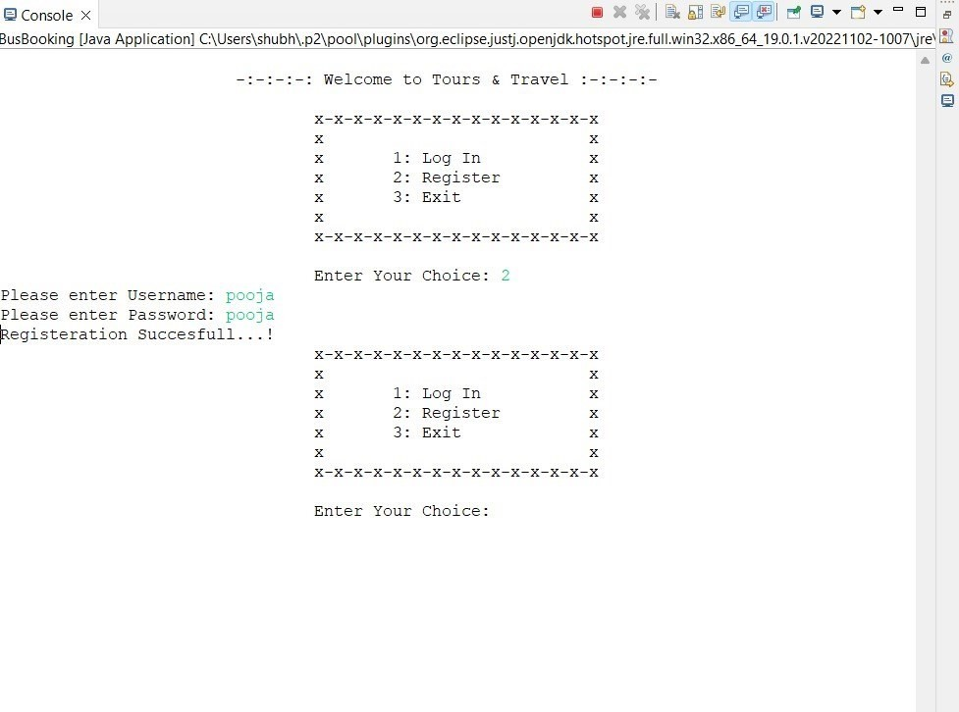

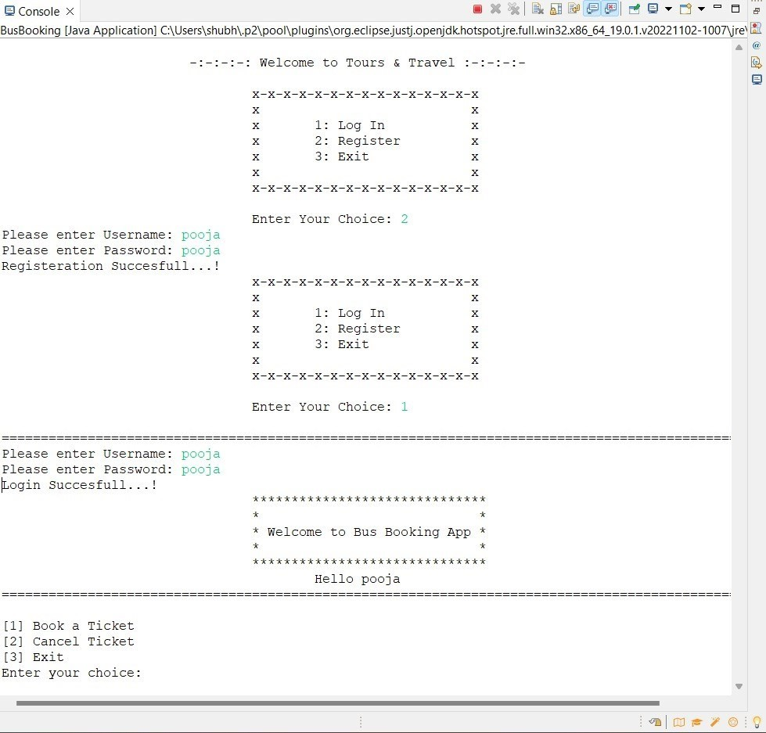**Login Page:**

**Book Ticket:**

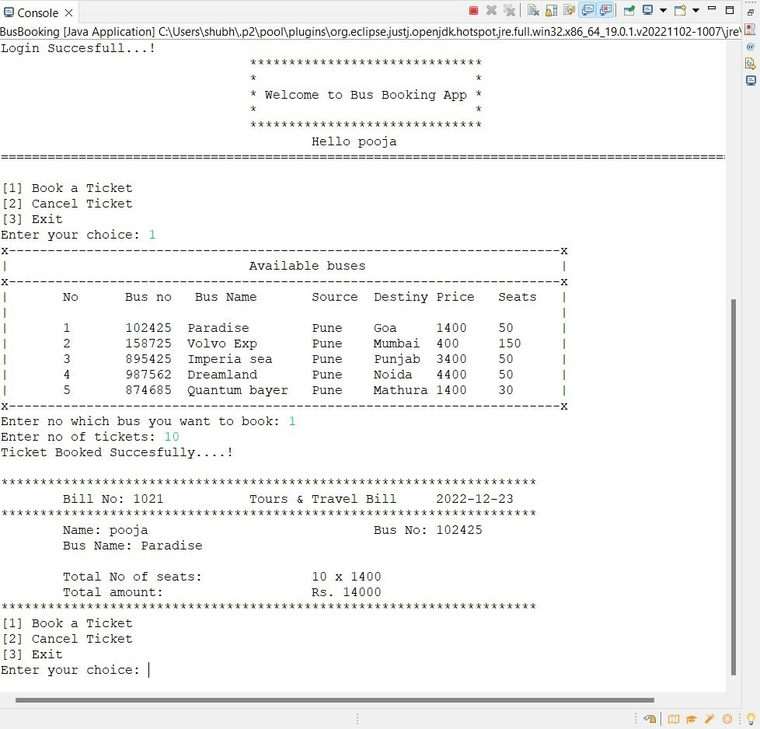

# Cancel Ticket:

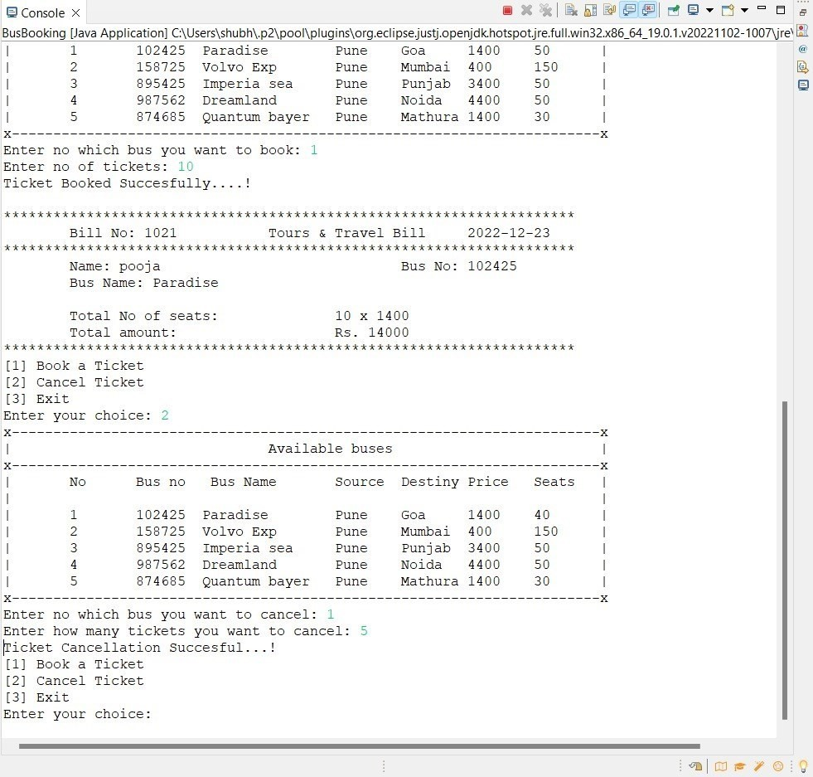

**Admin Login:**

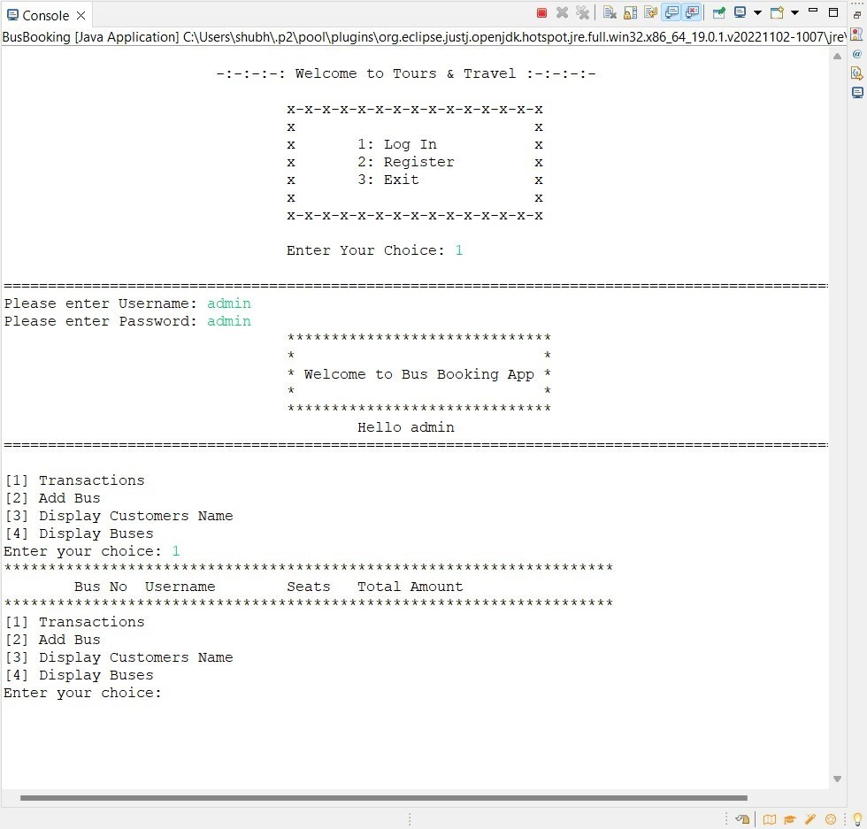

**Add Bus:**

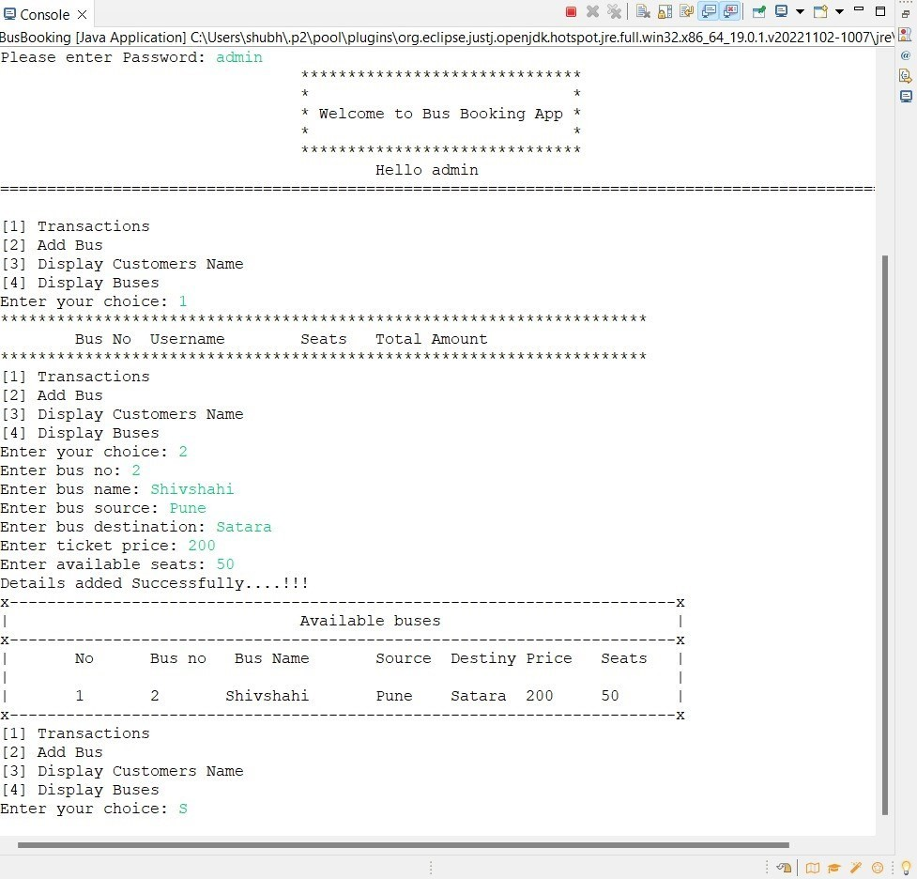

**Thank you….**